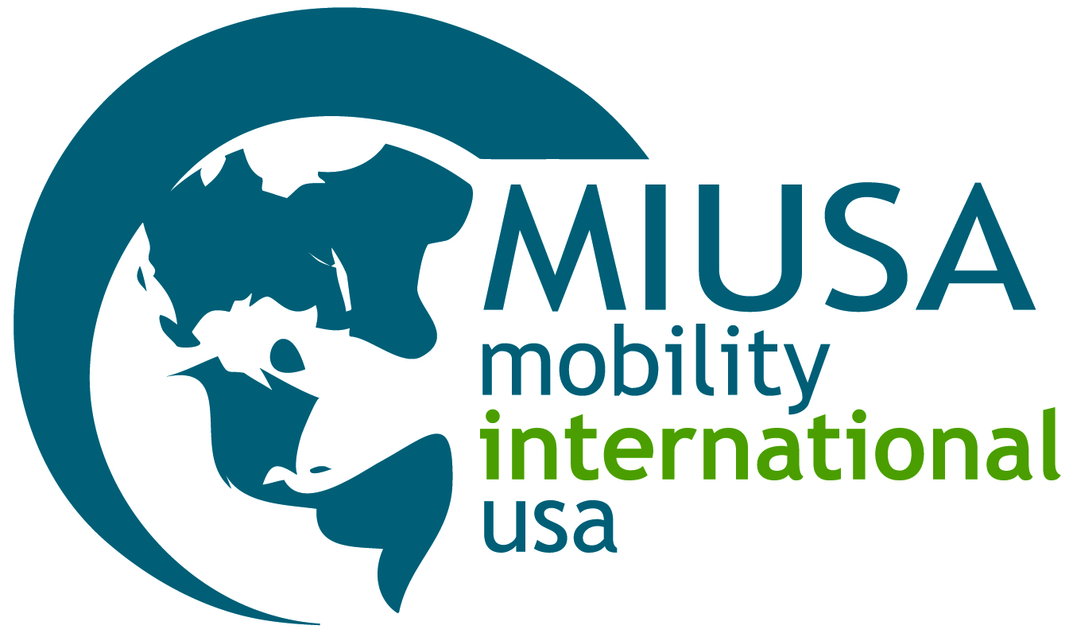

# STARTING FROM “YES”, GETTING TO “HOW” Making inclusion of people with disabilities a reality in your organization’s work

People with disabilities comprise approximately 15 percent of the world population and their successful involvement in all aspects of international development is crucial. What if all CEOs and staff, at headquarters and in the field, embraced disability inclusion as a human rights issue, and began each discussion about people with disabilities with “yes, inclusion is a priority”? We would then be able to focus all of our energy, resources and training on the "how."

This **simple rapid assessment** will assist all international development organizations to move from “yes” to “how.” After you complete the assessment, we invite you to visit MIUSA’s website for a comprehensive list of resources, including MIUSA’s *Building an Inclusive Development Community:* *A Manual on How to Include People with Disabilities in International Development Programs* (available at [www.miusa.org](http://www.miusa.org)).

## THE ASSESSMENT

### Part I: Policy framework

My organization:

* Utilizes a human rights framework when strategizing on disability inclusion issues, as opposed to a medical model.
* Complies with the USAID Disability Policy and Acquisition and Assistance Policy directives (AAPD-04-17 and AAPD-05-07). [*www.usaid.gov/about_usaid/disability/*](http://www.usaid.gov/about_usaid/disability/)
* Complies with the Americans with Disabilities Act (ADA). [*www.ada.gov/*](http://www.ada.gov/)
* Recognizes the Convention on the Rights of Persons with Disabilities and how it can be used to further inclusive development. [*www.un.org/disabilities/*](http://www.un.org/disabilities/)
* Recognizes inclusion of people with disabilities in mainstream development activities as essential for achieving the Millennium Development Goals. [*www.includeeverybody.org/*](http://www.includeeverybody.org/)
* Has its own organizational mandate/policy on disability inclusion.

*Case examples:*

*In Mongolia,* ***Mercy Corps*** *provided training for all their staff on the Convention on the Rights of Persons with Disabilities and the human rights model of disability.*

*In Ethiopia, the* ***USAID*** *mission is working closely with local disabled people’s organizations to create a comprehensive disability inclusion plan to implement USAID’s Disability Policy.*

### Part II: Organizational structure and governance

My organization:

* Recruits people with disabilities as interns, staff and/or board members.
* Hires staff with disabilities to work not only in areas related to disability projects, but also on a broad range of other issues.
* Employs people with disabilities, and particularly women with disabilities, in senior decision-making positions.
* Trains staff on disability inclusion as a cross-cutting issue.

*Case examples:*

***World Vision International*** *employs a disability advisor at its U.S. headquarters.*

*In Mongolia,* ***Mercy Corps*** *made changes to its recruitment policy to promote disability inclusion, hired new staff with disabilities, and made its offices accessible with ramps and signage.*

### Part III: Programs

My organization:

* Utilizes national and international organizations that work with disabled people around the world to recruit staff, consultants, board members, advisors, volunteers and interns.
* Invites people with disabilities and their organizations to our conferences or events.
* Builds relationships with local disabled people’s organizations.
* Makes our commitment to disability inclusion visible (i.e. images of people with disabilities are on our website, posters and brochures; language in written materials encourages people with disabilities to participate in our programs).
* Supports or partners with organizations led by people with disabilities.
* Makes disability inclusion part of solicitations in project proposal and evaluation criteria and assigns a score for inclusion.
* Collects and disaggregates data by disability and gender.
* Sets a minimum target for the percentage of beneficiaries who will be people with disabilities.
* Includes people with disabilities in all sectors of our work, not only disability specific programs (i.e. microfinance, HIV/AIDS prevention and education, gender initiatives, youth programs, education and business training, emergency preparedness and response, health, civil society strengthening and leadership training, democracy, governance and elections, conflict and refugee programs, water and sanitation, food security and agriculture).
* Includes people with disabilities in all stages of the development process from planning and implementation to monitoring and evaluation.
* Allocates a percentage of our budget (typically 3- 5 percent for program costs, 1-3 percent for administration costs) for reasonable accommodations to make our programs accessible to people with disabilities (e.g., sign language interpreters, accessible transportation and alternate formats).
* Ensures our offices, meeting spaces and training sites are accessible (e.g. ramps and bathrooms).
* Provides information in alternate formats and uses accessible communications (e.g., Braille, large print, electronic format, captioned videos technologies to facilitate website use).

*Case examples:*

***Trickle Up*** *achieved its original target that at least 10 percent of the beneficiaries in their entrepreneurship programs worldwide must be people with disabilities.*

***Hesperian*** *develops free community health resources in collaboration with disabled people’s organizations such as A Health Handbook for Women with Disabilities and Disabled Village Children.*

***American Jewish World Service*** *provides capacity building support to grassroots organizations. In Peru, it supports a grassroots organization led by women with disabilities. As a result, the voices of women with disabilities are included in public debates in Peru for the first time in history. The organization provided significant input on disability rights legislation in the Peruvian Congress.*

*In* ***WaterAid****’s project in Mali, in consultation with people with disabilities, water wells were made accessible to people in wheelchairs and to people who are blind.*

*In Colombia, the* ***International Office of Migration*** *is conducting training for their staff with local disabled leaders.*

When leaders of development organizations embrace inclusive development as good development, then we can begin with “yes” and move to “how.” One way to counter preconceived notions about the potential of people with disabilities is to start from the premise that people with disabilities **will** be included in your programs. From there, when your organization receives a grant to implement a youth program, you would routinely begin with strategies to ensure that your outreach, programming and staffing will include youth with disabilities. When your organization launches an initiative for girls’ education or women’s political participation, you would routinely reach out to women and girls with disabilities.

When you look at your work and you see that your programs do not include a significant percentage of people with disabilities, you must ask yourself why. Then reach out to other organizations that can assist you to start bridging this gap. There are disabled people’s organizations and activists in every country and they are ready to begin partnerships with international development organizations.