# **Printing and Display Guidelines for the Brilliant & Resilient Photo Exhibit**

**Important note: Due to the complexities of international shipping, printing the Brilliant & Resilient Photo Exhibition is an option available only for non-U.S. hosting sites. Please carefully review the following guidelines if you are hosting the exhibit outside of the United States.**  
Printing guidelines:

* All photos and vignettes can be printed and mounted on light-weight, gator foam: 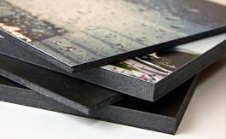
* All materials should be printed in color
* Matte laminate finish is recommended for text panels
* Glossy laminate finish is recommended for photo panels
* Borders around photos and text are optional. The photos can be printed to the edge of the foam board (full bleed)

**The total print job will be 62 pieces mounted on gator foam. (63 pieces, if printing Spanish version of exhibition). This includes:**

* 30 photos total:
  + Twenty of the photos printed the same size, each 26" x 30" (72 cm x 44 cm)
  + Ten photos which have slightly different lengths and widths, so these will all need to be printed custom sizes and mounted on different size foam boards
* 30 vignette text panels, each 16" x 20" (41 cm x 51 cm)
* 2 information panels, each 16" x 20" (41 cm x 51 cm)
  + About Photographers
  + Information about the Exhibit and MIUSA
* If the Spanish version of the exhibit will be displayed, a sponsorship of the Spanish translation sign will need to be printed, which is 8 ½” x 11” (22 cm x 28 cm)

*Please note: Materials do not have to be printed exactly to these measurements, but should be as close as possible in order to preserve the resolution quality of images and size of text.*

Exhibition Display Options **Option 1: Exhibit displayed for one month using an existing wire hanging system on walls**  
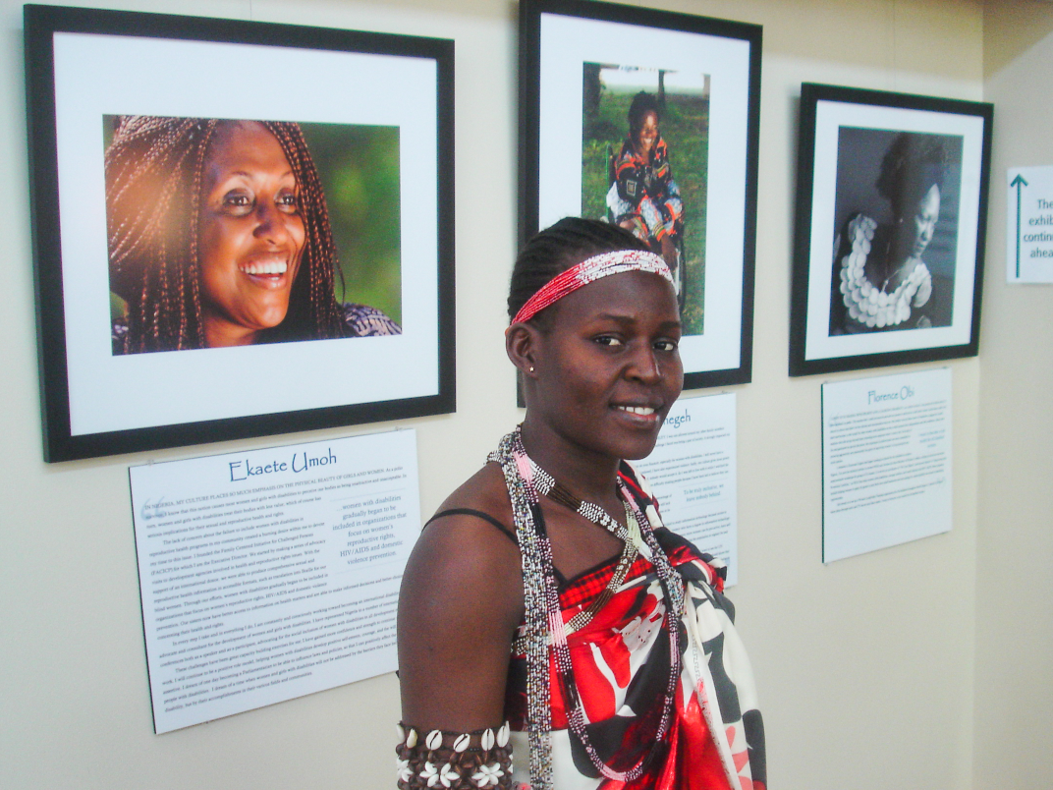

**Option 2: Exhibit displayed on screens for one week. All photos and vignettes printed on gator foam and attached with double sided adhesives. (Screens were rented)**

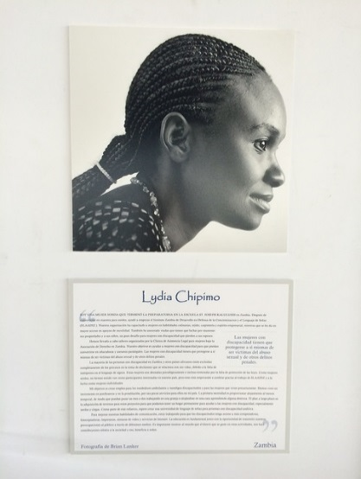 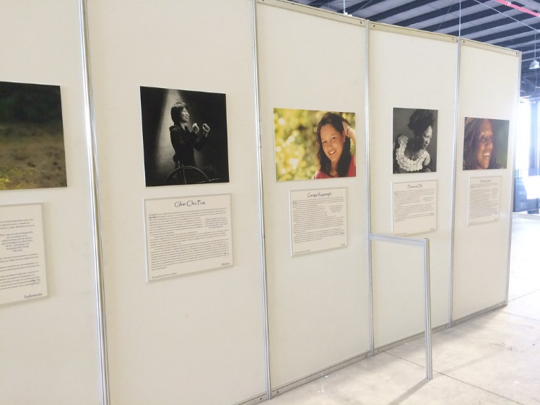

**Option 3: Exhibit displayed for a few hours on floor easels and table easels (Easels were rented)**  
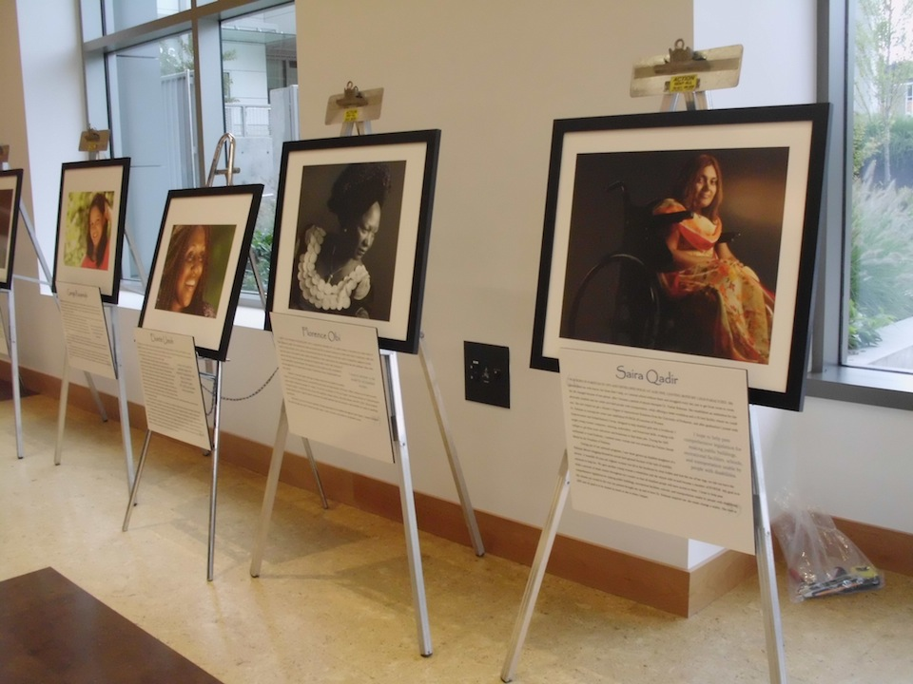 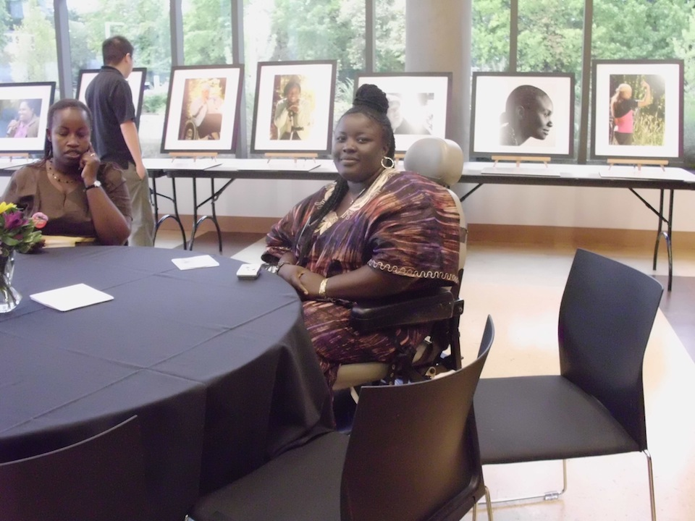

Hanging hardware options:  
  
Once you know how the exhibition will be displayed, decide which method to use for hanging. Here are a few options we have used:

* Sawtooth foam board hangers (Easy to install, but not the most stable option)  
  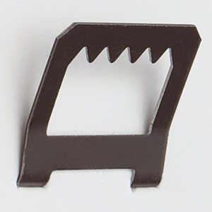
* Attach picture hanging wire to light weight adhesives or metal hangers (Most stable)  
  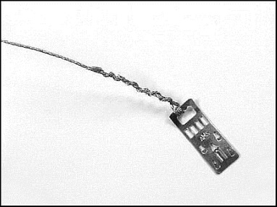 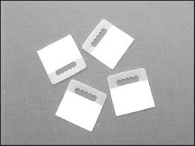
* Double sided adhesives attached to back corners of foam board (Easy and quick to install but difficult to remove and not re-usable)  
  