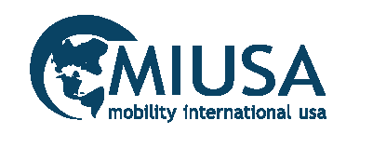

2012 - 2017

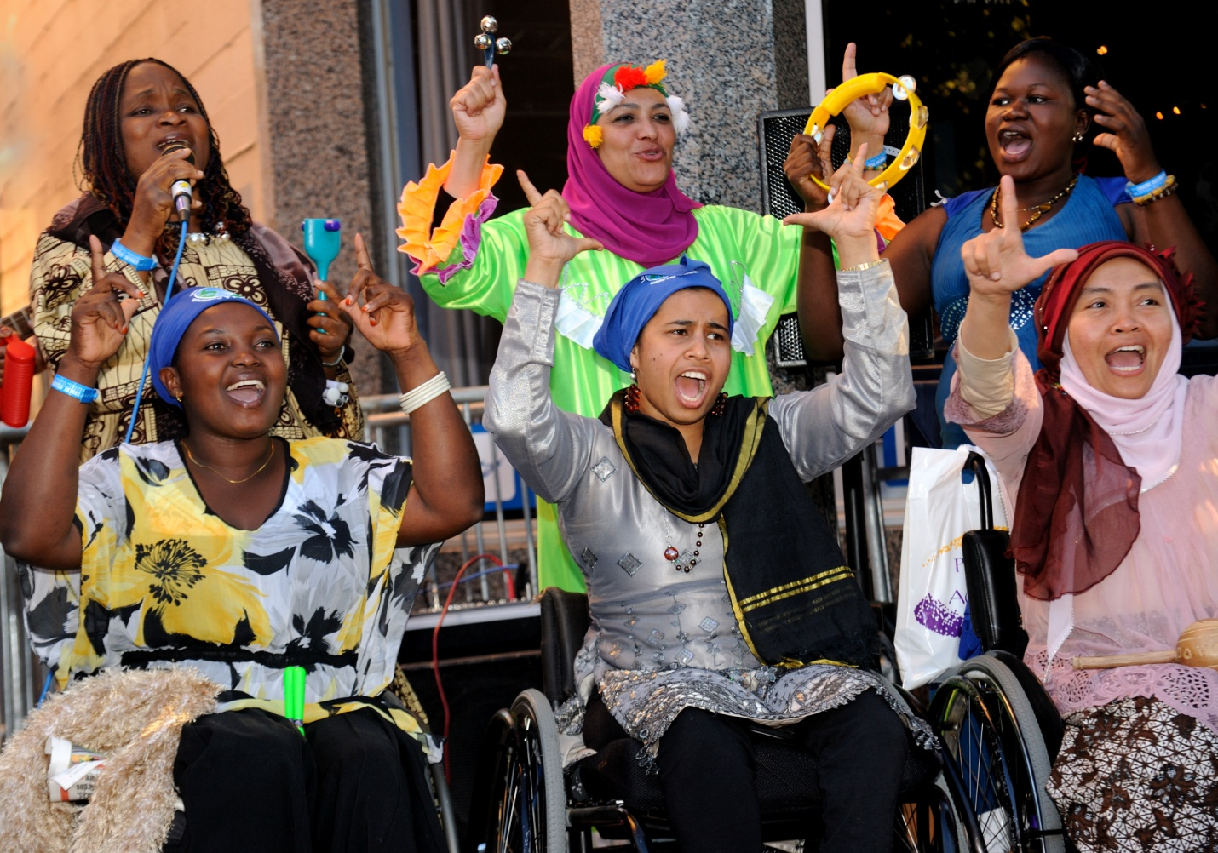
WILD SEED GRANTS PROGRAM
Photo credit: www.kiefelphotography.com
Table of Contents
Overview 4
2012 – 2013 PROJECTS 4
Chile 4
India 6
Ghana 7
Bangladesh 8
Nigeria 9
Armenia 10
Zimbabwe 12
South Sudan 13
Fiji 14
///Rwanda 15
2013-14 PROJECTS 16
Ghana 18
Barbados 20
Burkina Faso 22
Nepal 25
Myanmar 26
Cambodia 27
Mali 29
Bangladesh 30
Summary of WILD 2016-17 In-country Trainings 30
Armenia 31
Bangladesh 31
Botswana 31
Colombia 32
El Salvador 32
Ethiopia 33
Haiti 33
Kenya 34
Liberia 34
Malawi 34
Myanmar 35
Nepal 35
Nigeria 36
Panama 36
Philippines 37
South Sudan/Uganda 37
Tanzania 38
Uganda 38
Uruguay 39
Vanuatu 39

WILD SEED GRANTS PROGRAM

Overview
Putting the infiltration strategy to the test, Mobility International USA (MIUSA) awarded grants to alumni of the Women’s Institute on Leadership and Disability (WILD) program from 2012 - 2017. The main objectives were to continue building their capacity as leaders and to develop long-term partnerships with international development and human rights organizations working in their communities.
Grantees proposed and implemented projects ranging across a variety of sectors including gender-based violence, HIV/AIDS, reproductive health, education, sports/fitness, women’s leadership, IT skills training, and more.
In total, the seed grants supported WILD alumni in 33 countries. In 2012 – 2014, seed grants support WILD participant action plans. In 2016-17, the seed grants supported WILD Participants to implement WILD In-country trainings.
The WILD Seed Grants programs were administered by Mobility International USA and sponsored by the Channel Foundation.

2012 – 2013 PROJECTS

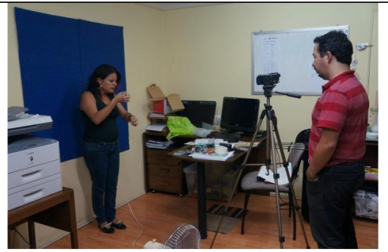
Chile
Vianney Sierralta creates of video of the Chilean HIV/AIDS law in sign language.
Area of Focus: HIV/AIDS prevention
Organization: Agrupación Regional de Personas Viviendo con el VIH/SIDA (ARPEVIH)
Grant Award: $1,000
Project: Informing Deaf Women of Chile about HIV/AIDS
ARPEVIH is a Chile-based organization whose primary mission is to empower and support those living with HIV/AIDS. Vianney Sierralta worked with ARPEVIH on a project to increase access to information regarding HIV/AIDs and reproductive and sexual rights to deaf women and girls. ARPEVIH worked in collaboration with the Deaf community to produce three videos on the following issues: Chilean Law on HIV/AIDS, Rights of people who live with HIV/AIDS; Sexual and Reproductive Rights of women; HIV/AIDS prevention for Deaf women; and general information on HIV/AIDS in sign language. It was the first time in Chile this information has been made available and publicly promoted in a video format utilizing Chilean Sign language interpretation and subtitles. Videos were uploaded to Youtube and Facebook. Eighty CDs were distributed to women leaders throughout the region. The videos were officially announced on July 13th, 2013. ARPEVIH and the participating deaf community groups have agreed to continue working together in the future.
YouTube Videos:
https://www.youtube.com/watch?v=bcnoN66F7sg
https://www.youtube.com/watch?v=Anqd0jPMaHs
https://www.youtube.com/watch?v=7ufC3dRLK8c

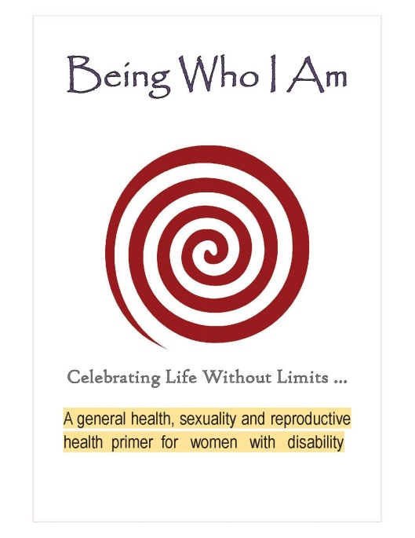
India
Cover page of the manual created with support from a WILD seed grant
Area of Focus: Women’s health
Organization: TEJAS
Grant Award: $1,000
Project: Developing an Information Package on Reproductive Health, Reproductive Rights and Sexuality for Women with Disabilities in the State of Tamil Nadu
TEJAS, a self-advocacy group for women with disabilities, collaborated with international and national mainstream women’s organizations, Women in Development (IWID), East West Centre for Counseling and Training, and Women’s Collective, and Hesperian Health Guides to create an information package on reproductive health, reproductive rights and sexuality for women with disabilities. The collaboration also included the expertise of a sexuality consultant and public health consultant.
The information package was distributed throughout the various districts of Tamil Nadu in accessible formats, such as braille, digital accessible information system (DAISY), and picture communication. This is the first time that information on sexuality and reproductive health have been developed in accessible formats to suite the access needs of women with different disabilities in India.
The project also educated the involved mainstream organizations on disability issues through the process, so that they will include women with disabilities in their future activities, programs and services. As a result of the sensitization trainings, these women’s groups realized the need and responsibility to include and involve women with disabilities in all matters concerning women.
TEJAS continues to work with the organizations and consultants to conduct orientation programs on sexuality, reproductive health care, sexually transmitted diseases and the available support services for women with disabilities in different parts of the State of Tamil Nadu. Tejas has been invited to be involved in the decisions and activities of the Regional Social Forum, a platform that mainstreams different perspectives, links various networks, and services as a strong tool for collective advocacy, to be conducted in 2014 in Chennai.

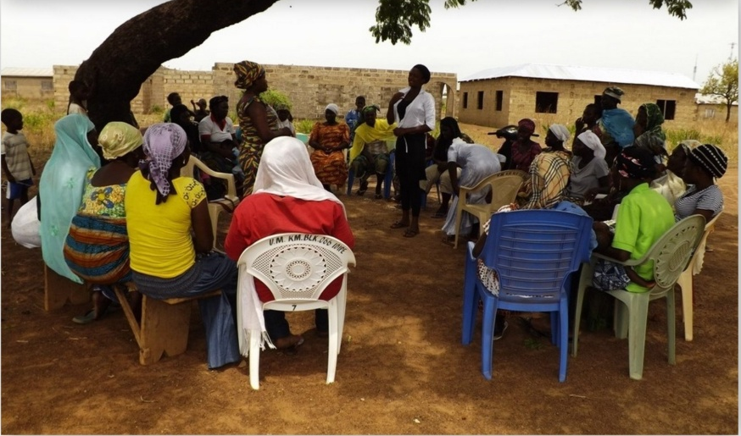
Ghana
Zuwera Fuseini facilitates an informative workshop on HIV/AIDS prevention.
Area of Focus: HIV/AIDS Prevention
Organization: Mental Health Society of Ghana (MEHSOG)
Grant Award: $990
Project: Increasing knowledge and understanding of HIV/AIDS among fifty women and girls with psychosocial disabilities in Salaga Ambrase
The Mental Health Society of Ghana (MEHSOG) implemented an HIV/AIDS education project working in partnership with BasicNeeds, an international development organization, and the Salaga Government Hospital. MEHSOG aims to promote the socio-economic wellbeing of people with mental illness and/or epilepsy and advocate for the advancement of mental health.
Persons with psychosocial disabilities are often excluded from most educational and sensitization programs, though they are one of the most vulnerable groups affected by HIV/AIDS in Ghana. Because of superstitious beliefs, they become victims of sexual abuse by people infected with HIV who hold the erroneous impression that sex with a person with a mental disability will help cure HIV. It is especially important to educate people with mental health disabilities especially in rural areas, where access to information is difficult.
The workshop informed 50 girls and women with psychosocial disabilities on the issues of HIV/AIDS. According to the baseline assessment conducted prior to the workshop, 90% of the participants had no formal education on the subject beforehand. After the intervention, 30% of participants voluntarily tested for HIV.
The project offered a unique opportunity for renewed technical collaboration between MEHSOG and BasicNeeds. MEHSOG established a new partnership with the Salaga Government Hospital which provided voluntary counseling services to participants after the workshop. MEHSOG intends to replicate the training in other rural areas targeting their membership base of over 20,000 people in over 40 districts of Ghana.
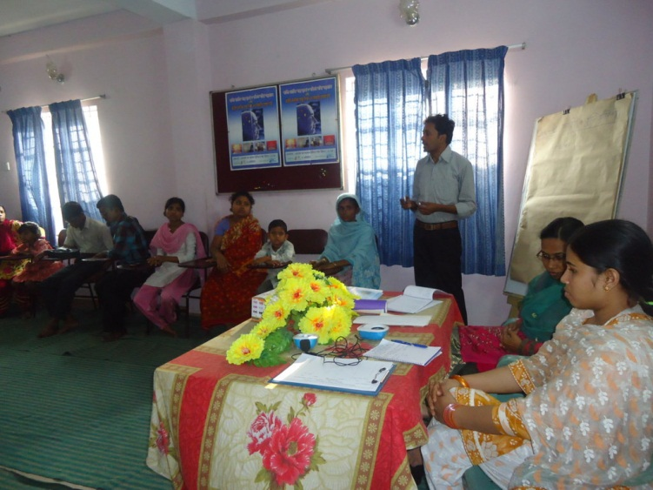
Bangladesh
Farida Akther of Disability Rights Movement facilitates a sharing meeting with one of their development organization partners.
Organization: Disability Rights Movement (DRM)
Grant Award: $1,000
Project: Promoting Women with Disabilities as empowered human beings with dignity through networking meetings with 5 development NGOs
Disability Rights Movement (DRM) is a non-governmental organization in Bangladesh that strives towards empowering persons with disabilities and ensuring their basic human rights. DRM implemented a project focusing on disability inclusion in various sectors: employment, inclusive education, empowerment, reproductive health and information technology. DRM collaborated with five development organizations of Chittagong which included: Unite Theatre for Social Action (UTSA), Young Power in Social Action, Songsoptaque, Nowzuwan, and Borony. The project consisted of a series of networking meetings with the development NGOs.
As a result of the networking meetings, 13 women with disabilities are being trained in different skill development from three of the NGOs: Young Power in Social Action (YPSA), Unite Theatre for Social Action (UTSA) and Songsoptaque. Five Women with disabilities are now receiving a monthly allocation as part of the Lactating Mothers Project from Women and Children Affairs Office of the Bangladesh Government. Five people with disabilities have been placed into jobs in the nongovernmental and corporate sector. Five children with disabilities are now attending inclusive schools through advocacy of UTSA & DRM. Ten women with disabilities are getting free medical facilities from the government hospital. Three female students with disabilities are receiving one-year scholarship from the Lions Club for continuing their education.
DRM and the development NGOs would like to continue conducting similar activities and are seeking funding for future collaboration.
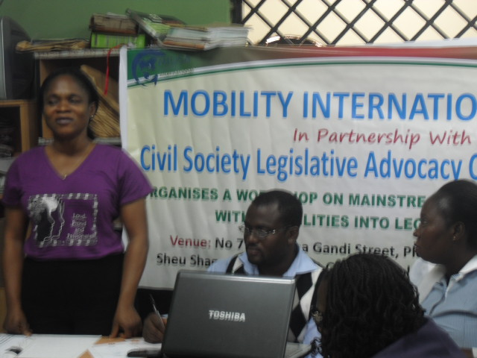
Nigeria
Sarah Akinola of the Joint National Association of Persons with Disabilities Nigeria (JONAPWD) makes a presentation on disability inclusion to the staff of Civil Society Legislative Advocacy Center (CISLAC)
Organization: The Joint National Association of Persons with Disabilities Nigeria (JONAPWD)
Grant Award: $1,000
Project: Workshop on mainstreaming issues of Persons with Disabilities in Civil Society, Legislative and Advocacy programs
The Joint National Association of Persons with Disabilities Nigeria (JONAPWD) is an organization committed to addressing the training, rehabilitation, social and recreational needs of persons with disabilities in Nigeria. JONAPWD worked in partnership with Civil Society Legislative Advocacy Center (CISLAC) to ensure that people with disabilities are included in CISLAC’s programs by conducting trainings for CISLAC staff.
On behalf of JONAPWD, Sarah Akinola trained over 20 staff from CISLAC on how to provide reasonable accommodations for people with disabilities in programs and activities. As a result, CISLAC took immediate steps to make their physical environment accessible to all persons with disabilities, and they continue to seek consultation from JONAPWD.
The two organizations have begun collaborating in other ways. For example, representatives from CISLAC were invited to attend JONAPWD’s national convention in May, and CISLAC facilitated the inclusion of persons with disabilities at a meeting on the State of the African Union and in one of their programs focused on the role of civil society organizations in national policy reform. JONAPWD and CISCLAC are currently seeking funding to collaborate on another project that will focus on educating people with disabilities on civil rights.
Armenia
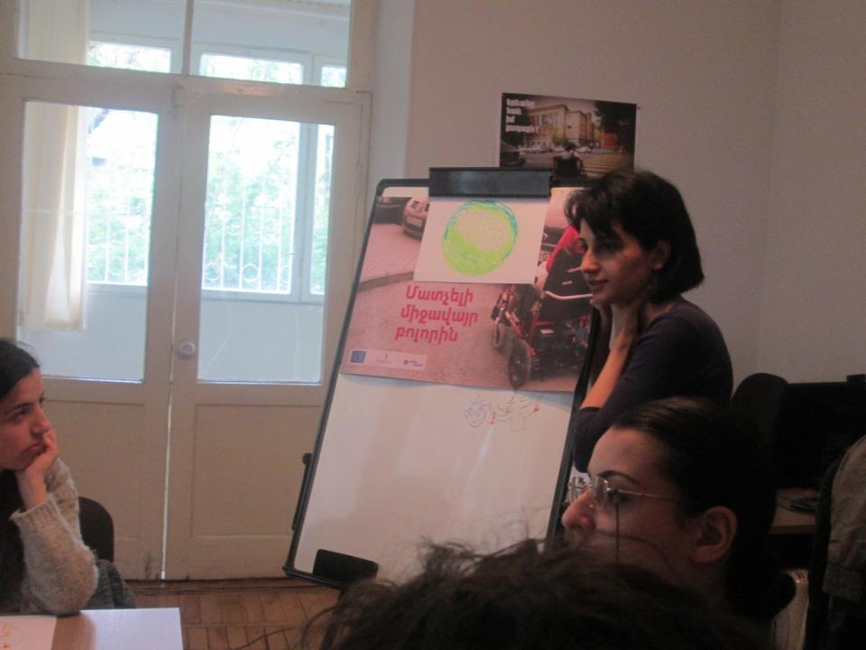
Organization: Bridge of Hope
Grant Award: $980
Project: Go Ahead Girls
Zaruhi Batoyan implemented a project to increase public awareness of the challenges faced by women with disabilities, and the need for creating better accommodations and inclusive services. The project involved multiple components and was also supported by Bridge of Hope, Ms. Batoyan’s organization, and the Disability Advocacy Coalition.
Women’s Resource Centre Armenia and the Disability Advocacy Coalition facilitate a training for women with disabilities to examine sexual and reproductive health issues.
As one component of the project, Bridge of Hope partnered with the Women’s Resource Centre Armenia (WRCA), a feminist organization that aims to empower women to become active citizens. A seminar was held for eight WRCA staff on how to make their programs more inclusive of women with disabilities. WRCA and the Disability Advocacy Coalition then collaborated to provide two, three-day trainings for 23 women with disabilities. The trainings included art therapy, mental/psychological exercise, and examined issues pertaining to sexual and reproductive health.
Other related project activities included a roundtable discussion hosted by the Institute for War and Peace Reporting, in which Ms. Batoyan presented on the need for inclusive services. The discussion was attended by more than 25 people from five NGOs and 5 media organizations. In addition, 8 journalists from 6 media organizations were trained on how to address issues of disabled women in the media. Nine young women with disabilities were trained on developing skills in journalism and blogging. A blog was then created to allow them to share their experiences, access information and develop a support network. The website for the blog is: http://ikin.am/ (which means iwomen). The project concluded with a press conference for NGOs and the media, in which women with disabilities presented the challenges they face, the importance of developing inclusive services, the blog and their work.
Project partners plan to collaborate in the coming months to conducted trainings for women with disabilities on women’s human rights. They will also continue to update the blog’s content.
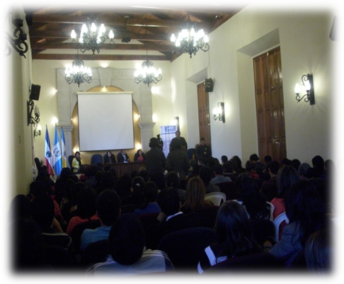
Guatemala
One of the monthly municipal mayors meetings in Quetzaltenango
Organization: Association of Women with Disabilities Quetzaltenango (AMUDIQ)
Grant Award: $1,000
Project: Municipal Authorities and People with Disabilities “Rights and Duties”
The Association of Women with Disabilities Quetzaltenango (AMUDIQ)’s mission is to represent and empower women with disabilities to achieve independent living conditions of genuine equality. AMUDIQ worked in partnership with the Interior Department of Quetzaltenango to bring the issues of women with disabilities to the attention of the mayors from 24 municipalities in Quetzaltenango.
Initially, a survey was sent to the mayors to gain an understanding of current efforts to include and outreach to women with disabilities. They found a lack of understanding of disability issues and women with disabilities were not taken into account in any program or service. An hourly slot was then dedicated each month (from April – June) at the municipal mayors meeting to focus on issues pertaining to people and women with disabilities, especially indigenous women with disabilities, and the responsibilities of the Municipal authorities toward these populations.
Upon completion of the project, mayors had a better understanding of the rights to representation for women with disabilities in the community. Through these efforts, the Mayor of San Mateo, a municipality of Quetzaltenango, donated land to build a special education school, and the Development Council of Quetzaltenango committed to providing the financial support for building the school. In addition, the Women Presidential Secretariat (SEPREM) is now reaching out to women with disabilities in their job employment programs for the first time. AMUDIQ was also invited to participate in the project Quetzaltenango Just and Trustworthy for the Working Rights of Vulnerable Groups, with the Ministry of Labor and the International Labor Organization (ILO). The AMUDIQ and the Interior Department of Quetzaltenango continue to follow-up with the Mayors in each municipality to establish self-help groups.
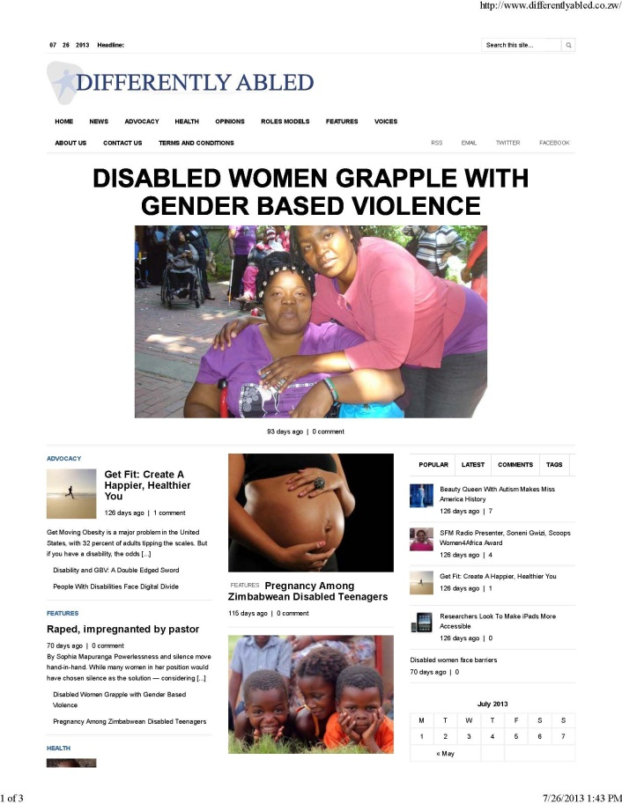
Zimbabwe
Screen shot of the new website, Differently Abled, created as part of the WILD seed grant project.
Organization: The Epilepsy Support Foundation of Zimbabwe
Grant Award: $1,000
Project: Differently Abled Website
Viewing information and knowledge as a source of power, Sally Nyakanyanga used her seed grant funds to develop a website dedicated to exploring and articulating a range of disabled women’s issues. The website is a forum to raise awareness in the Zimbabwean community and other countries on disabled women issues and offer solutions. Her organization, the Epilepsy Support Foundation of Zimbabwe, also provided support with content and personnel to develop the website.
Ms. Nyakanyanga invited several disability organizations and women’s organizations to contribute to the website’s content. Participating organizations included: the Christian College of South Africa, Epilepsy Support Foundation of Zimbabwe, Zimbabwe Women’s Coalition, Disability HIV/AIDS Trust, Young Nation, Disabled Women Support Organization, and the Autism Organization of Zimbabwe. The website also provides information, links, and opportunities for women with disabilities from other organizations. The development of the website allowed Ms. Nyakanyanga to establish new partnerships with these organizations. She has also begun to build relationships with some international donors such as UN Women, the U.S. Public Affairs Section of the Embassy, and UNICEF to further develop the website’s content.
The “Differently Abled” website can be accessed through the following link: www.differentlyabled.co.zw
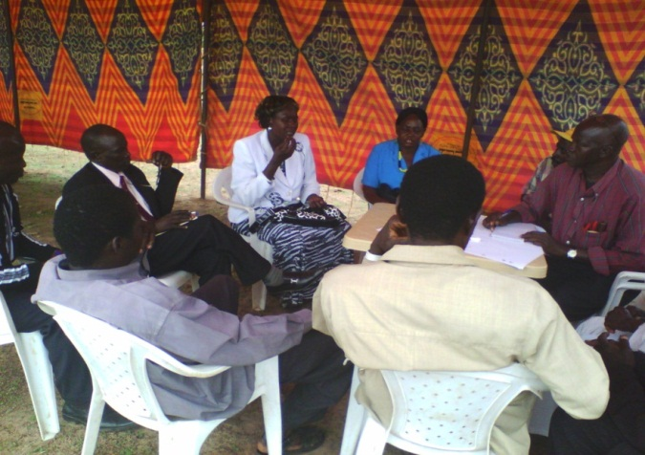
South Sudan
Participants in one of the small group breakout sessions share their views on what they believe should be included in the permanent constitution on issues regarding people with disabilities.
Organization: The Southern Sudan Deaf Development Concern
Grant Award: $950
Project: Outreach to People with disabilities for programs in 5 States
The Southern Sudan Deaf Development Concern implemented a project to increase civic participation of people with disabilities, especially women with disabilities, across five states of South Sudan. With support from Handicap International, they conducted outreach to people with disabilities across the country to include in the project. The project provided an opportunity to network with several development organizations including: Justice Africa, Voice for Change, South Sudan Law Society, South Sudan Women Empowerment Network, United States Agency for International Development (USAID), Media House, UN Women, International Rescue Committee (IRC), and various national civil society organizations working in South Sudan.
As part of the project, Caroline and her team fostered organization of women with disabilities groups. They met with women with disabilities to identify their issues and unite for one common goal, to ensure the rights of people with disabilities, especially women with disabilities, be included as part of the permanent constitution of South Sudan. Discussions were also held with prominent women leaders from the Ministry of Gender and Social Development to ensure women with disabilities would be included in their programs related to women’s advocacy.
The project was successful in mainstreaming the issues of people with disabilities into the broader civil society agenda. Approximately 100 people, including 10 persons with disabilities, attended a seminar on Citizen’s Dialogue on the Constitution of the Republic of South Sudan. They participated in civil society technical committees working on issues related to advocacy and ensuring citizen participation. Their views were stated and submitted to the National Permanent Constitution Review Commission to be considered during the drafting of the permanent constitution of South Sudan.
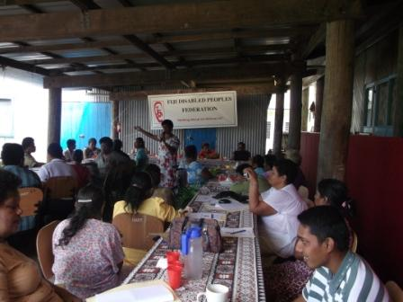
Fiji
Fiji Ministry of Health and Empower Pacific conduct an HIV/AIDS awareness workshop for women with disabilities on International Women’s Day.
Organization: Fiji Disabled Peoples Federation (FDPF) Women’s Group
Grant Award: $1,000
Project: Sexual Reproductive Health and HIV/AIDS awareness workshop for International Women’s Day
The Fiji Disabled Peoples Federation (FDPF) Women’s Group partnered with the Fiji Ministry of Health and Empower Pacific, an NGO that provides community awareness and education on HIV/AIDS, to conduct an HIV/AIDS awareness workshop on International Women’s Day, March 8th, 2013.
Representatives from the Ministry of Health and Empower Pacific facilitated the 5-hour workshop on HIV/AIDS and distributed information regarding prevention techniques. FDPF partnered with the Housing Assistance Relief Trust, which provides low cost housing for many women with disabilities, to reach out to women with disabilities in villages outside of the capital city of Suva. The workshop was originally planned for twenty participants, however they were successful in convening a total of 40 women with diverse types of disabilities for the workshop.
The development partners Empower Pacific and the Ministry of Health greatly appreciated the opportunity to be involved in the workshop, as it was the first time they had conducted training for women with disabilities and this provided them the opportunity to learn how to ensure their trainings were disability-inclusive. The two organizations are looking forward to conducting similar workshops for women with disabilities in the future. They plan to inform the FDPF women’s committee of other opportunities for engaging women with disabilities in their programs.
///Rwanda
Organization: National Organization of Users and Survivors of Psychiatry (NOUSPR)
Grant Award: $970
Project: Raising Hope: Outreach to people with psychosocial disabilities and indigenous women with disabilities
This project brought together the expertise of multiple organizations to improve outreach to people with disabilities in development programs. On behalf of her organization, National Organization of Users and Survivors of Psychiatry (NOUSPR), Ms. Ntwali worked with Volunteer Service Organization (VSO), URUFATIRO Foundation, and the National umbrella of Disability Organizations in Rwanda (NUDOR) to develop training materials on inclusion and outreach to people with disabilities.
Partners contributed to the project in different ways. NOUSPR provided meeting space and supplies, VSO provided expertise in programs for people with disabilities, URUFATIRO provided information on gender based issues, while NUDOR promoted the project through their national network. After collecting the experiences from project partners at preparation meetings, Ms. Ntwali developed training materials and conducted a training for program staff of partner organizations on inclusion of people with disabilities, with a particular focus on indigenous women with disabilities and women with psychosocial disabilities. As part of the training, role plays and training material illustrations were used to demonstrate how to address disability accommodation issues in the workplace.
Ms. Ntwali intends to design additional promotional materials and develop an awareness campaign on accessible services and working environment of people with disabilities to be accomplished by May 2014.

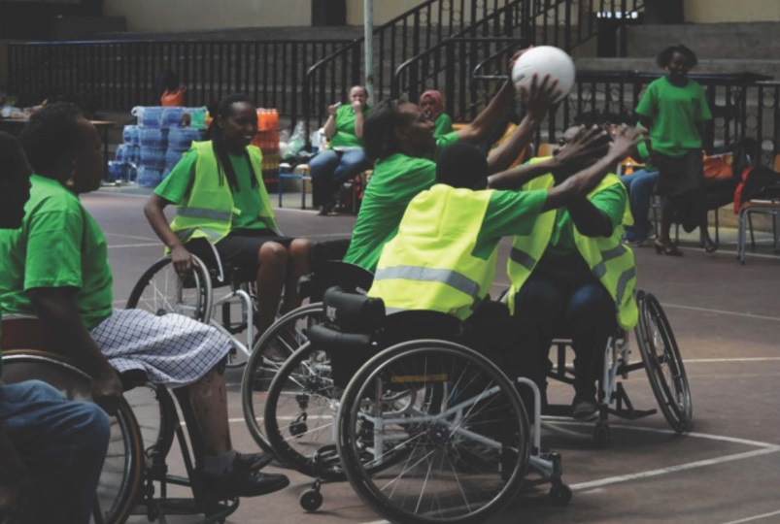
2013-14 PROJECTS
Kenya
Area of Focus: Sports/Fitness and Women’s Health
Organization: ThisAbility Consulting
Partner organization: Women's Therapy Place
Grant amount awarded: $1,000
Project Description: Lizzie Kiama, founder of ThisAbility Consulting, organized a one-day “Women & Wheels” workshop. The workshop brought together 29 women with and without disabilities to play wheelchair rugby and incorporated facilitated discussions on gender-based violence, health, sexual and reproductive rights. The overall goal of the project was to provide an opportunity for women with disabilities and professionals working in development organizations to develop relationships in a fun, interactive environment. The project included a disability sports expert from the Ministry of Sports and a coach. A medical doctor was also invited to lead an interactive session on Health and Fitness, which included practical exercises for keeping fit and maintaining a healthy lifestyle. Participants also had a Question & Answer session with the doctor to address their health questions and concerns. The workshop was also supported by other sponsors including Nokia, Coco Cola, Raerex, and Kenya Commercial Bank, who donated goods.
After the amazing success of the WILD seed grant funded workshop held in October 2013, other funders committed to supporting more “Women & Wheels” workshops. In March 2014 the Pollination Project supported another workshop, and in May 2014 the Ford Foundation and Family Health Options Kenya were sponsors. Abilis Foundation plans to support the next workshop in August 2014 and the Kenya National Fund for the Disabled and Kenya Re-Insurance will support a fifth workshop in November 2014.
In addition to funding, other organizations have supported the “Women & Wheels” workshops in other ways. Family Health Options Kenya offered free sexual and reproductive health services (e.g. on-site cancer screening and family planning provided); TICAH facilitated talks on bodies and sexuality; and The Action Foundation worked to include mothers of children with disabilities. USAID has also taken an interest, and through their financial services project, FIRM, they are assisting ThisAbility Consulting to establish a comprehensive model and expand their reach.
There were many unexpected outcomes from this innovative project. The project has influenced other organizations to be more inclusive of women with disabilities. For example, a microfinance organization, Kiva, has offered women with disabilities access to finances to start and grow their small businesses. Coca Cola Kenya will be including women with disabilities in their global 5by20 campaign which is aiming to empower 5,000,000 women by 2020.
The Women & Wheels project was nominated by the US Embassy in Nairobi for the US Department of State and espnW Global Sports Mentoring Program in September, 2014. The project was featured on Citizen TV, a national television station. Watch the video clip on YouTube: https://www.youtube.com/watch?v=LbqSh3udyJc

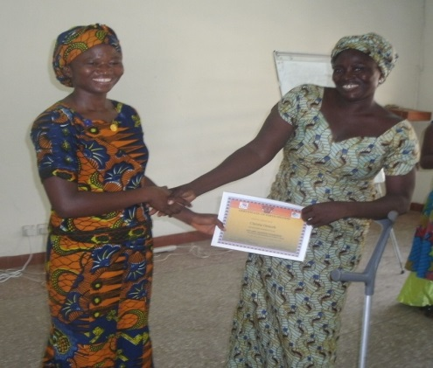
Ghana
Area of Focus: HIV&AIDS
Organization: Ghana National Association for the Deaf - Upper West Regional Women`s Wing
Partner organization: Ghana Health Services Municipal Health Directorate (MHD)
Grant amount awarded: $995
Project Description: GNAD’s Women’s Wing partnered with the Ghana Health Services Municipal Health Directorate to conduct an HIV/AIDS and health education workshop for 27 young women with disabilities. Participants represented a cross disability group (i.e. blind, physically disabled, deaf, etc.). The workshop provided information to young women with disabilities on the risks of contracting HIV, avoiding unwanted pregnancies, and how to access information related to personal health. Participants were also encouraged to share strategies for ensuring inclusion in mainstream services with the invited resource persons.
Through this workshop, the resource persons, facilitators, and experts in the field became better prepared to deliver their services and programs to women and girls with disabilities. The discussions that followed resulted in MHD pledging to recruit a full time sign language interpreter in some selected health centers.
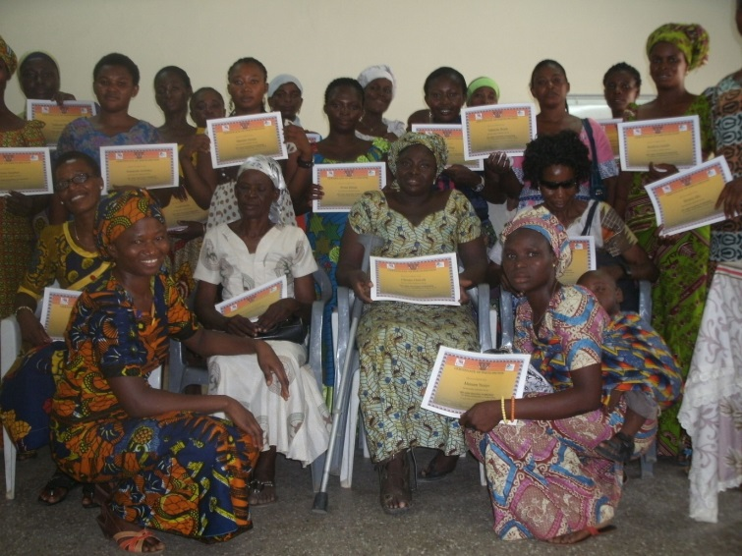
A follow up visit was made to partner organizations to assess how they are using the skills acquired from the training program. Outcomes included a new collaboration between the Upper West Region Association of the Deaf Women’s Wing and the district to train nurses in basic sign language. Regional Representatives of the Deaf Women’s Wing are now fully involved in decision making with other disabled peoples’ organizations. There are also plans for another program on reproductive health to target students in two special schools, Wa School for the Deaf and Wa School for the Blind.
Other partners involved in the project included the Ghana Blind Union; Ghana Society of the Physical Disability; and National Health Insurance Authority.
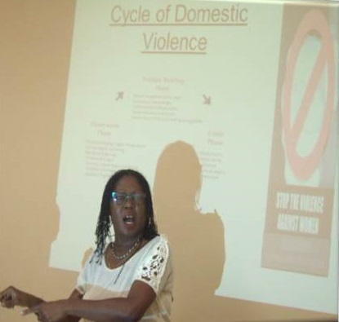
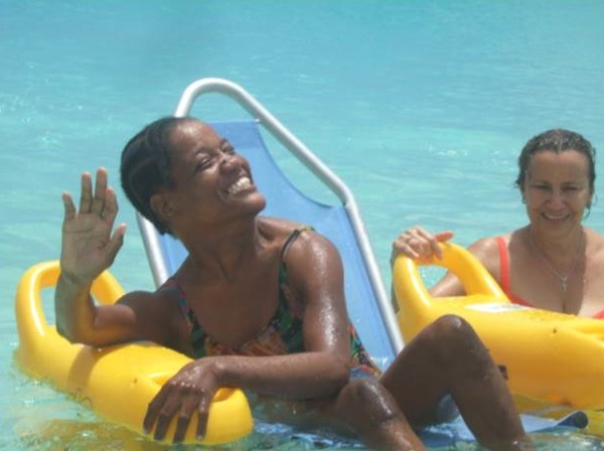
Barbados
Area of Focus: Women’s leadership and gender-based violence
Organization: The Barbados Council for the Disabled
Partner organization: Business Professional Women’s Club of Barbados (BPW)
Grant amount awarded:$1,000
Project description: Twelve women with disabilities between the ages of 18 – 45 participated in six, three-hour workshop sessions. The workshops were aimed at enhancing women with disabilities’ personal image, leadership skills and building their capacities. The project, entitled ‘The Breakfast Club’, was organized in collaboration with the Business Professional Women’s Club of Barbados (BPW). Session topics included: Becoming Empowered, Being a Self-Advocate, Personal Imaginary, Getting Pumped – Physical Activity (Beach Activity), You Have Rights, and Sexual Reproduction Health.
Although the major partner was the Business and Professional Women’s Club of Barbados (BPW), the workshops presented opportunities for building relationships between several other organizations and the Barbados Council for the Disabled. Invited speakers shared opportunities to explore and tap into certain services being extended by their agencies. For example, during the sexual and reproduction health workshop, participants learned about the Crisis Hotline, Crisis Centre and a Shelter for Abused Women, which provides a safe-house for women & children with various counselling and intervention services.
One of the main goals was to prepare participants to train other women with disabilities, within their organizations or within the wider society. Although concrete plans have not yet been made for replicating the trainings, UNWomen pledged their support to the concept of the Breakfast Club as a possible ongoing program for the future. Future collaborations will include consultation to ensure BPW facilities are accessible, delivering a disability sensitivity training program for BPW personnel, and recruiting people with disabilities to be trained in the area of counseling in order to service the Crisis hotline.
A DVD is currently being developed as a result of this project which will be linked on the Council’s website. The Council is looking forward to continuing its partnership with BPW.

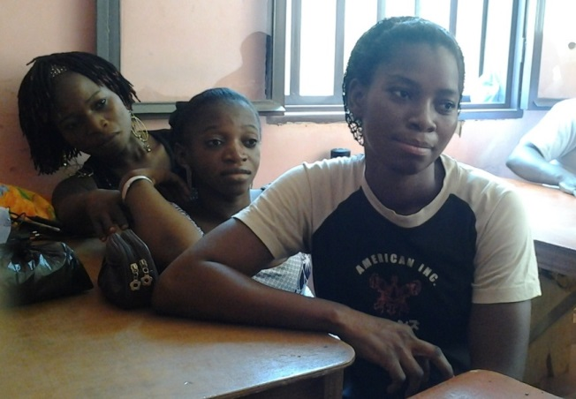
Burkina Faso
Area of Focus: Education
Organization: Handicap Solidaire Burkina
Partner Organization: Ajud Africa (development NGO focused on education)
Grant amount awarded: $981
Project Description: A three-day workshop was conducted for twenty women with different types of disabilities (hearing, visual, mobility disabilities) from Ouagadougou and rural provinces. Staff of partner organization, Ajud Africa, were invited to participate and learn about the importance of access to education for people with disabilities, especially girls and women. The workshops focused on the situation of women and girls with disabilities in Burkina Faso, the right to education, and the role of the state and NGOs in the inclusion of disabled people. The workshops looked specifically at ways to include women with disabilities in Ajud Africa’s existing and future education programs.
Now that this project is complete, Ajud Africa is committed to work in partnership with Handicap Solidaire Burkina to sustain their inclusion practices. A major project has been initiated by the Ministry of Education, which agreed to support an inclusive literacy program of Ajud-Africa. It has taken action to see it implemented at the national level by facilitating educational access to blind and deaf people. This program will be implemented by the Ministry in 2015.
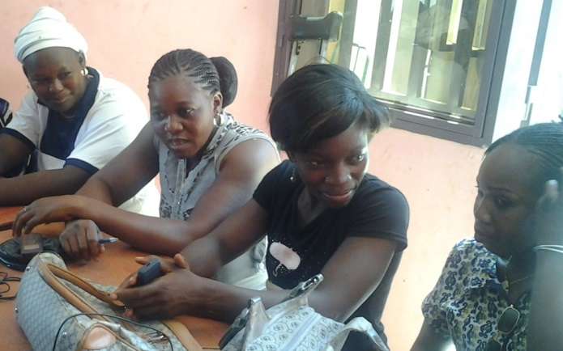
Another unexpected outcome of the workshop was that, in addition to making the participants more aware of their rights to participate in education programs, it also resulted in the women with disabilities forming an entrepreneurship group, which is now being supported by the Ministry of Gender Promotion and Women rights.
The workshop led to the creation of several new partnerships. In addition to Ajud-Africa, relationships were built between the associations of disabled people, representatives from the Ministry of Human Rights, the Ministry of Health, the Ministry of Solidarity and Social Action, and the Ministry of Education.
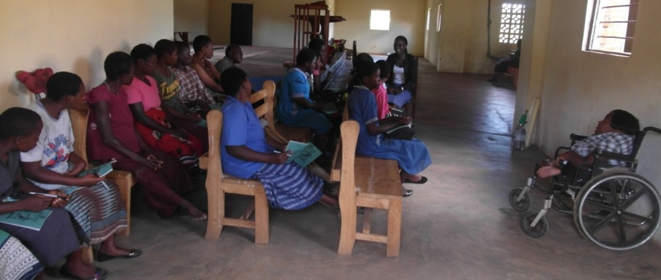
Malawi
Areas of Focus: Disability rights, HIV/AIDS, gender based violence
Organization: Forum for the Development of Youth with Disabilities (FDYD)
Partner Organization: Korean National Commission for UNESCO (KNCU)
Grant amount awarded: $1,000
Project Description: FDYD worked collaboratively with KNCU to conduct a series of group sessions and a training to mobilize 60 girls and young women with disabilities in their community. The sessions addressed disability rights, HIV/AIDS, and gender-based violence.
Although FDYD had previously collaborated with their partner, KNCU, to serve children with disabilities in one district, this was the first time KNCU focused specifically on girls with disabilities. For this project, FDYD provided guidance and orientation for KNCU volunteers so that they were able to learn how to work and interact with girls with disabilities and disabled peoples' organizations when they returned to their respective districts. As a result, KNCU has started incorporating issues of disability in their various areas of operation in Malawi.
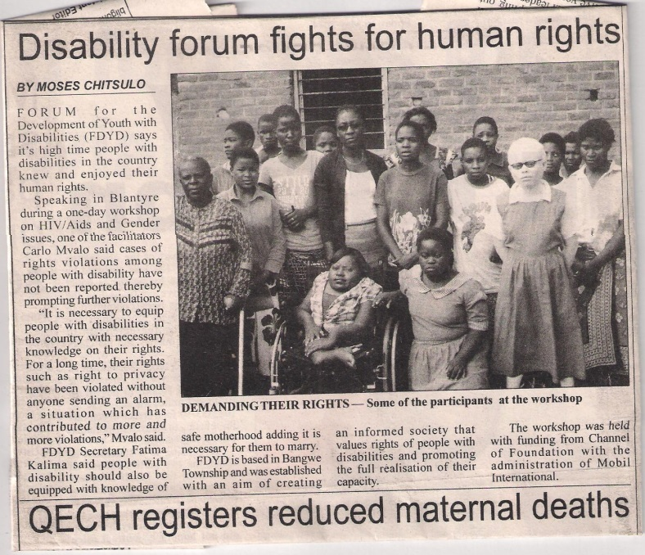
The workshop and meetings were very productive and the project brought to light many of the obstacles facing girls and women with disabilities in their everyday life. The participants came to the realization that the high rates of abuse suffered by women with disabilities is a violation of their human rights. The workshop helped girls with disabilities to feel comfortable voicing their concerns and to speak up whenever their rights have been infringed. As a result of the training, there has been an increase on reporting of cases of abuse, with approximately 4 -5 cases reported each month.
FDYD plans to continue holding monthly meetings with the girls and young women with disabilities. They want to conduct another similar training, as they considered the pilot training to be only an introduction. Eventually, FDYD hopes to select young women with disabilities to form an active women with disabilities group who can replicate trainings in other communities around the region. FDYD also plans to continue working with KNCU to expand their work to include girls with disabilities in other project areas, such as adult literacy and income generating activities. They also want to encourage KNCU to expand their disability inclusion work to other countries where they are presently working, including Zambia, Zimbabwe and Lesotho.
An unexpected outcome of the project was due to the increased visibility of FDYD’s work through media coverage on national radios and daily papers. As a result, Fatima was invited to attend a training on feminism and human rights in June 2014. She was the first person with a disability to attend.

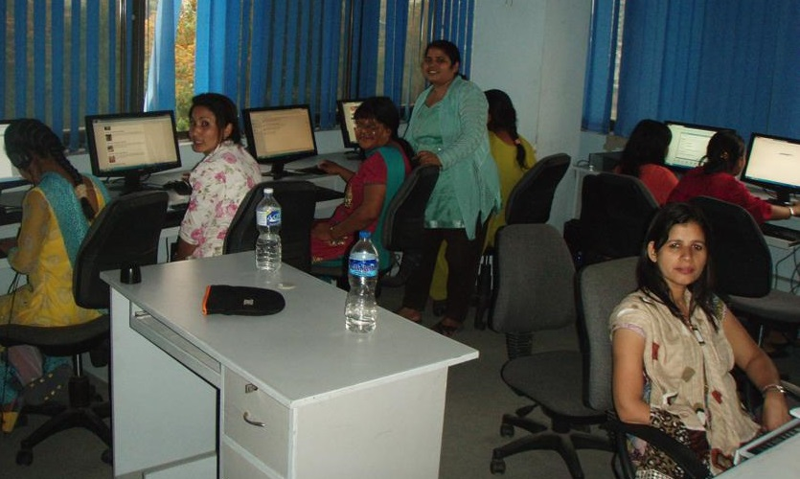
Nepal
Area of focus: IT Educational Training
Organization: KOSHISH (Mental Health Self Help Organization)
Partner organization: Internet Society (ISOC) (a U.S. based international nonprofit)
Grant amount awarded: $972
Project Description: KOSHISH partnered with Internet Society Nepal to implement a 6-day training on internet technology for 10 women and girls living with different disabilities (e.g. physical, mental, deaf, and blind). Internet Society Nepal is a professional organization that works in the area of rights perspective of ICT and ICT training for disadvantaged people. It was an opportune time to involve KOSHISH (an organization focused on mental health rights) in such activities. ISOC is very committed to the goal of inclusive development and collaboration with KOSHISH. Although ISOC Nepal has a broader scope of work, they want to make disability issues an integral part of their work. They are planning to organize more activities in the area of ICT and Disability, as this is one of the themes they are working on for the year 2014. They have formed a "social inclusion subcommittee" and a person with disability is a member of this committee.
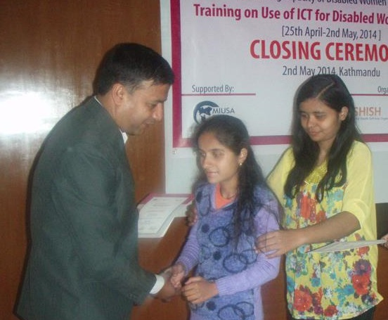
KOSHISH was able to provide guidance and orientation for ISOC staff to help conduct the training. KOSHISH reached out to other disability rights organizations, inviting them to send representatives to participate. The training adopted adult learning methods and disability-friendly tools while implementing the project.
This ICT training program was the first of its kind to be conducted for women and girls with disabilities in Nepal. Women and girls with various disabilities worked together for the purpose of the training. This was a new and interesting experience for the organizers as well as the participants. “It was an opportunity to develop friend circles and to expand their professional horizons,” shared Susmeera, “It will certainly aid the disability rights movement in Nepal.”

Myanmar
Area of focus: Women’s Leadership and disability rights
Organization: Exponential Growth Organization (EGO)
Partner organization: Gaihahita (environmental organization)
Grant amount awarded: $910
Project Description: Exponential Growth Organization (EGO) collaborated with Gaihahita to conduct a three-day training for 20 participants, which included 12 young women with disabilities and 10 young women without disabilities. An additional eight guests were invited from government ministries, donors, the business sector, development organizations and women organizations. These participants were invited to the training so they could better understand how they can benefit from the skills, commitment, and strength of women with disabilities. The training included several workshops on variety of topics such as, using a human rights framework, education, employment, inclusive development, gender equality, and covered relevant national and international laws. After completing the workshop, all delegates were equipped with the skills to advocate to local authorities for inclusion of women and girls with disabilities in community development processes.
Through this collaboration, disabled youth are being included in more mainstream youth activities. EGO and Gaihahita are continuing to work together to advocate for inclusion in youth and civil society sectors. They are working to influence policy makers and the private sector in Myanmar to understand the benefits of engaging with disabled people’s organizations in order to reach out to youth with disabilities to be part of the decision making processes for sustainable development. For example, they recently selected five young people with disabilities who participated in the “Leadership and Disability” workshop to attend a training on Ecological living, hosted by the environmental organization Alin Ein.

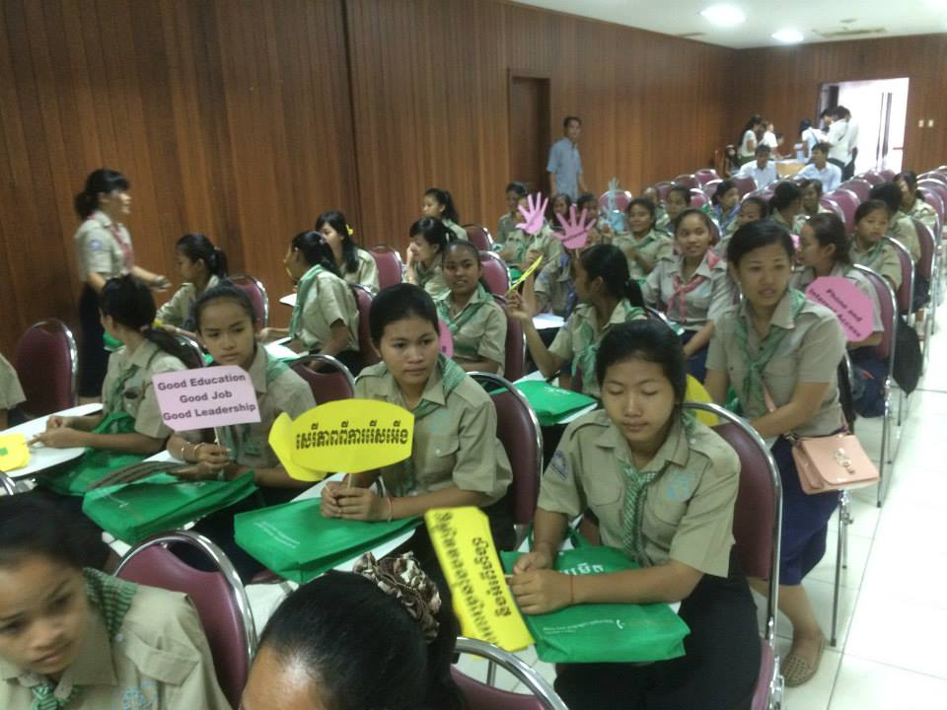
Cambodia
Area of focus: Girls leadership and disability rights
Organization: Action on Youth with Disability for Development (AYDD)
Partner organization: Girl Guides Association of Cambodia (GGAC)
Grant amount awarded: $1,000
Project description: Action on Youth and Disability for Development collaborated with Girl Guides Association of Cambodia to jointly implement a workshop for 106 young people with and without disabilities, including 78 females and 28 males. The workshop covered rights, laws and situations of girls and women with disabilities. It also provided an opportunity for participants to share experiences about the role of girls and women with disabilities in society and see examples of successful women leaders with disabilities. The women and girls with disabilities were provided a chance to express their needs and learn how to increase the self-esteem in order to be more independent. The young people without disabilities who participated in the workshop were made aware of the rights and requirements of women with disabilities, and their capacity to participate in society.
By jointly implementing this workshop, the partner organization, Girl Guides Association, understands and continues to give priority to issues of girls and women with disabilities in their work and empower girls and women with disabilities in their communities and focus areas.
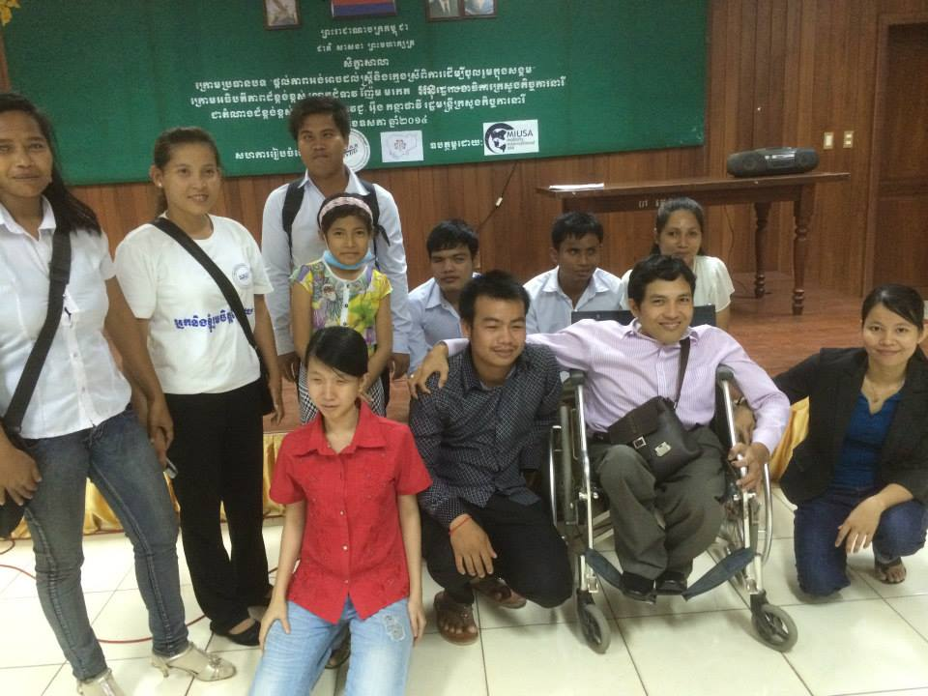
In addition to the primary project partner, Girl Guides Association of Cambodia (GGAC), other partnerships included the Phnom Penh Center for Independent Living (PPCIL), Cambodia Trust (CT), Cambodian Disabled People’s Organization (CDPO); Komar Pikar Foundation (KPF), Handicap International (HI), Deaf Development Program (DDP), Art Group of People with Disabilities, the Ministry of Women’s Affairs, and Amret Micro-Finance Institution.
The workshop was covered by local TV, radio and newspaper. The Ministry of Women’s Affairs also publicly recognized the importance of the workshop and the need to ensure women with disabilities are fully included in the development planning processes in Cambodia.

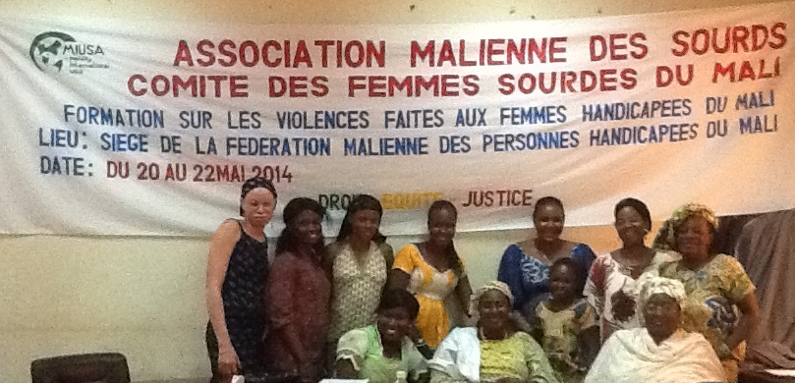
Mali
Area of focus: Prevention of violence against women
Organization: Committee of Deaf Women of Mali (CDWM)
Partner organization: CECI (a Canadian development NGO)
Grant amount awarded: $1,000
Project Description: The Committee of Deaf Women in Mali partnered with CECI to conduct a three-day workshop on prevention of violence against women. CECI is a Canadian development NGO whose work in Mali focuses on governance, gender, fundamental human rights, community health, and economic and social development.
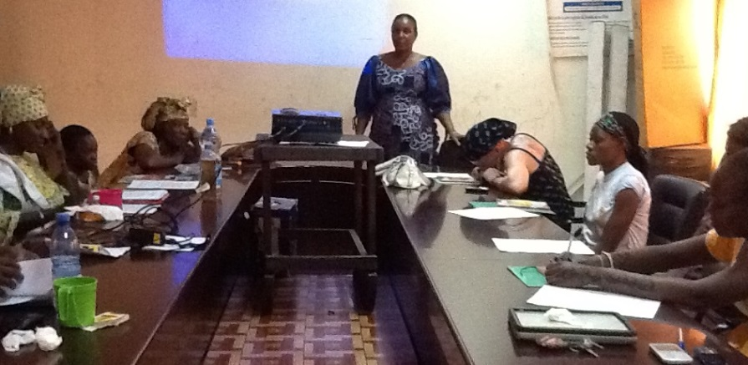
Both CECI and CDWM provided trainers for the workshop and worked collaboratively to conduct the training. Eight women participated in the workshop, including six women with different types of disabilities, such as physical, blind, deaf, and albinism, and two women without disabilities. Participants learned about legal instruments, types of violence, and discussed issues concerning violence against women with disabilities. CECI staff led the legal training content for the workshop. Handbooks on the Convention on the Rights of Persons with Disabilities were given to each participant.
Following the project, CECI remains committed to continuing to build the capacity of women with disabilities who participated in this project. They have offered to provide financial support to CDWM to produce a play about violence against women with disabilities in October 2014.
In addition to the partnership with CECI, CDWM also worked with the Malian Federation of Associations of Disabled People of Mali (FEMAP) and the Malian Union of Women with Disabilities of Mali (UMAFH) to implement the training.

Bangladesh
Area of focus: Employment and women’s issues across a variety of sectors
Organization: Women with Disability Development Association (WDDA)
Partner organizations: Bangladesh National Women Lawyers Association (BNWLA), Bangladesh Nari Progoti Shongho (BNPS), Chittagong Society for Development Forum (CSDF), OWDEB, and the Alliance of Urban DPO’s in Chittagong (AUDC)
Grant amount awarded: $1,000
Project Description: The Women with Disability Development Association (WDDA) conducted a series of networking meetings with senior staff of five women and development NGOs to sensitize these organizations to the needs of women with disabilities and explore opportunities for collaboration. Organizations included: BNWLA, an organization working in Chittagong City to prevent women’s rights violation through providing legal support; BNPS, a national NGO working for ensuring rights and empowerment of girls and women through vocational training; CSDF, a network organization of NGOs in Chittagong that works on gender-based violence, women empowerment and gender issues; OWDEB, a national women’s organization that works for women empowerment in rural areas through training, education, advocacy, micro-credit programs, and skill development program. They also met with AUDC, an alliance of DPOs to ensure women and girls with disabilities are prioritized in their activities as well. Through these networking meetings, mainstream organizations made commitments to including women and girls with disabilities in their work across a variety of sectors.
As a result of this project, mainstream women’s organizations in Bangladesh are more disability-friendly. Twenty five women with disabilities were placed in vocational training programs, ten of which are now qualified for employment both in governmental and non-governmental positions, and six women have already found jobs. Twenty-five family members of women with disabilities were also sensitized about the rights of women with disabilities through the networking meetings.
For next steps, WDDA is planning to work with AUDC and other development organization partners to implement the project “Access to Justice For All”, to continue promoting rights of women with disabilities.

2016-17 Projects

Armenia
Anush Arakelyan
Equal Rights, Equal Opportunities, led by WILD delegate, Anush Arakelyan, implemented a WILD training for women with disabilities in Armenia.
The training was held on November 6th, 2016 at the Getap Resort in Dilijan.
The participants included 20 women with all different types of disabilities between the ages of 17-40, coming from rural and urban districts in the Lori region.
The overarching theme of the training was leadership skills development, with workshops on reproductive and sexual health, and parenting and childbirth. The women practiced yoga and played Keglies (bowling) for empowerment activities.
This training was done in partnership with the YMCA, and the Agate Center, for women with special needs.

Bangladesh
Lisi Desai
Turning Point Foundation, led by WILD delegate Lisi Desai, implemented a WILD-Bangladesh training for women with disabilities in Bangladesh.
The training was held on November 17th, 2016 at the Edward M. Kennedy-EMK Center (a branch of American Center, Dhaka).
The training was cross-disability program, including 21 women with all types of disabilities, between the ages of 20-40, and from both rural and urban areas.
The title of the workshop was “Boosting confidence of women with disabilities through self-defense and accessing to public life.” The training offered a platform for women to share experience, learn the principles of WILD, and participate in safety and self-defense demonstrations. The participants then traveled to the University of Dhaka for a picnic in the common area, as their empowerment activity.
The training was done in partnership with DREAM Foundation, The American Center, Dhaka, Women with Disabilities Development Foundation (WDDF), Caritas Bangladesh, and local DPO’s.

Botswana
Boikhutso Majang
Botswana Association of the Blind and Partially Sighted (BABPS), led by Boikhutso Majang, implemented a WILD training for women with disabilities in Botswana.
The training was held on December 9th, 2016 at the Youth Centre Auditorium located in Central Business Development in Gaborone.
Seventeen women between the ages of 21-45, from both rural and urban areas of Botswana participated in the training, representing women with all different types of disabilities.
The focus of the training was Women’s Health, Wellness, and Safety. Workshops addressed the topics of HIV/AIDS prevention, reproductive health, and gender based violence. The participants attended a film screening as their empowerment activity.
The training was done in partnership with Kagisanyo Women’s Shelter, and the Botswana Family Welfare Association.

Colombia
Camila Lozano
Asdwon Colombia, led by WILD delegate Camila Lozano, hosted a WILD-Colombia training for women with disabilities in Colombia.
The training was held on February 9th, 2017 at the Hotel Bh.
The participants included 22 women with all different types of disabilities between the ages of 18-40, coming from various regions of Bogotá.
The training focused on the topics of women’s health wellness and safety, leadership, and policy and legislation. The women practiced self-defense as their empowerment activity.
This training was done in partnership with Profamilia, Colombian Coalition for the Convention for People with Disabilities Implementation, and the Presidential Counselor for Women Equity (CPEM).

El Salvador
Angela Bonilla de Castillo
The Red de Sobrevivientes y Personas con Discapacidad, led by WILD delegate Angela Bonilla de Castillo, hosted a WILD-El Salvador training for women with disabilities in El Salvador.
The training was held on November 11th, 2016 at Rancho Costa del Sol” located in the municipality of La Herradura, La Paz department.
The participants included 22 women with all different types of disabilities between the ages of 15-50, the majority being leaders of DPOs and from urban areas. The focus of the training was on the topic of sexual and reproductive health, addressing common misconceptions and myths and introducing best practices. The participants went swimming at the pool as their empowerment activity.
This training was done in partnership with the National Council for Comprehensive Care for People with Disabilities (CONAIPD) and municipal authorities.

Ethiopia
Helen Teshome
New Life Teen Challenge Development and Relief Program, led by Helen Teshome, implemented a WILD training for women with disabilities in Ethiopia.
The training was held December 10th-11th, 2016 at the Addis Ababa University Center for Special Need Support.
The participants included 19 women with all types of disabilities between the ages of 15-35, from sub cities across Addis Ababa.
The training focused on the topics of inclusive health care and health services for women with disabilities. The women participated in self-defense training and adaptive sports as the empowerment activities.
The training was conducted in partnership with Dires Development Charitable Association, Addis Ababa University Special Needs Support Office, and other organizations will provide facilities and technical support.

Haiti
Mause-Darline Francois
Filles à Besoins Spéciaux pour la Réforme (FIBESR), led by WILD delegate Mause-Darline Francois, implemented a WILD-Haiti training for women with disabilities in Haiti.
The training will be held January 25th, 2017 at the Center for Inclusion at the Cristian Blind Ministries in Port-au-Prince.
The participants included 20 women with all different types of disabilities between the ages of 18-40, coming from across Port-au-Prince (Delmas, Carrefour, Pétion ville, Gressier, Croix-des-ouquets etc.)
The focus of the training was on Leadership, connecting women with local resources and information. The empowerment activities included a day at the fitness club. The women also learned about sports, practiced Zumba and yoga, and learned to use different fitness equipment.
This training was done in partnership with CBM, BSEIPH, Sant Kor Lavi, and IDEH.

Kenya
Jemimah Kutata
Mona Disabled Women Community Based Organization, led by WILD Delegate, Jemimah Kutata, implemented a WILD training for women with disabilities in Kenya.
The training was held on November 9th, 2016 and at the White Rhino Hotel.
The participants included 20 women with different disabilities, 18 years and above, coming from rural areas (Nyali, Changamwe, Likoni and Bamburi) that had not had the opportunity to participate in such a training.
The focus of the training was on Safe Sex and Reproductive Health, addressing how to increase accessible health services in public hospitals. For their empowerment activity, participants visited the City Center together, where there was dancing and markets.
The training will be conducted in partnership with National Council for Persons with Disabilities.

Liberia
Ballah Yamah
Lofa County Association of the Disabled, led by WILD delegate Ballah K. Yamah, hosted a WILD-Liberia training for women with disabilities in Liberia.
The participants included 20 women between the ages of 15-45, with all types of disabilities, and coming from across Lofa County.
The training focused on the topic of inclusive education, with an emphasis on parent advocacy, legislation, and methods of inclusion. The women practiced yoga and participated in an evening of music and dancing as empowerment activities.
This training was conducted in partnership with Social Empowerment through Learning (SELL).

Malawi
Scader Louis
Spinal Injuries Association of Malawi, led by WILD delegate Scader Louis, implemented a WILD-Malawi training for women with disabilities in Malawi.
The training was held November 28th, 2016.
The participants included 20 women between the ages of 25-40 with all different types of disabilities. Participants came from 4 districts in the Central region and 1 city in the south (Lilongwe, Mchinji, Kasungu, Dedza, Blantyre), these included both rural and urban areas.
The training focused on the topics of Policy, Legislation and Advocacy. As November is Malawi’s “Disability Awareness Month”, this training aligned with the month’s theme of creating awareness of Agenda 2030, the Sustainable Development Goals, as well as the implementation of the Disability Act.
This training was done in partnership with FEDOMA (the umbrella body of DPO’s in Malawi), SIAM, World Vision, and Sight Savers.

Myanmar
Tawng Mai Nhkum
Actionaid Myanmar, led by WILD delegate Tawng Mai Nhkum, implemented a WILD training for women with disabilities in Myanmar.
The training was held on January 22, 2017 at the Blind Christian Association Hall in Yangon.
Participants included 20 women, ages 20 and above, with all different types of disabilities. These women came from across 14 states and regions across Myanmar.
The focus of the training was on the topic of women’s health, wellness, and safety. Women had the chance to network with local women’s organizations in order to increase access to services for women with disabilities. The participants went to a fitness center as an empowerment activity.
This training was conducted in partnership with Myanmar Federation of Persons with Disabilities.

Nepal
Anjana K.C.
Independent Living Society – Nepal, led by WILD delegate, Anjana K.C., will host a 6 day WILD training for women with disabilities in Nepal.
The training included 40 women with different disabilities, age 14-40, from different DPOs located in Pokhara Sub-Metropolitan City and Lekhnath Municipality. Some participants came from Self-Help Groups (SHGs), located in rural areas of Kaski District.
The training was held January 24 – 25th, 2017 at the Hotel Saiman and Party Palace.
The focus of the training was on Sexual and Reproductive Health, including adolescent sexuality, life skills and positive sexual behavior, contraception methods, and safe abortions. The women also participated in the empowerment activity of boating on Lake Fewa.
The training was done in partnership with Marie Stopes, and the Kasi Blind Association.

Nigeria
Hellen Udoye
Deaf Women Association of Nigeria (Abuja Chapter), led by Hellen Udoye, implemented a WILD-Nigeria training for women with disabilities in Nigeria.
The training included 30 participants from both rural and urban areas in Abuja, Lagos, Jos, Anambra, Akwa-ibom, and Kaduna. The participants were between 18-35 years old, representing a range of all disabilities.
The training was held on December 17th, 2016.
The focus of the training was on women’s health, wellness, and empowerment. Topics included access to information and services, HIV/AIDS prevention, and sexual assault and domestic violence prevention. Empowerment activities included visiting a gym and dancing.
The training will be conducted in partnership with Ipas, Christian Blind Mission – Nigeria, Dorothy Foundation, and the News Agency of Nigeria.

Panama
Marissa Malema Martinez Samudio
Patronato Luz Del Ciego (Blind Patronage Light), led by WILD delegate Marissa Malema Martinez Samudio, hosted a WILD training for women with disabilities in Panama.
The training was held March 19 - 25, 2017 in the facilities of “Patronato Luz Del Ciego” and Hotel Panama, located in the City of Panama.
The participants included 20 women with different disabilities, between the ages of 18 – 50, from across 10 provinces and from indigenous communities.
The focus of the training was Leadership, Politics, Legislation, Advocacy, Health, Wellbeing, and Safety for Women, Disability and Development partnerships. The empowerment activity was a Challenge Course in a nature reserve park that will include challenging physical activities and teamwork to be able to complete each task. This workshop was led by a professional company with experience in this type of activities.
The WILD-Panama training also included MIUSA’s photo exhibit, Brilliant & Resilient: Celebrating the Power of Disabled Women Activists. The exhibition was an opportunity for dialogue and building new partnerships between women leaders with disabilities and human rights, development and government agencies.
The training was conducted in partnership with the National Secretariat of Disability (SENADIS), government institution, the Ministry of Health, the National Federation of Disability. They also partnered with the Rotary Club of Panama to obtain volunteers.

Philippines
Janice Aparri
Philippine Accessible Disability Services, Inc., led by WILD delegate Janice Aparri, will implement a WILD training for women with disabilities in the Philippines.
The training will be held in May 2017, at the Kool Adventure Camp (KAC) of the Ramon Aboitiz Foundation Inc. (RAFI).
The participants will include 20 women with all different types of disabilities, between the ages of 18-45, coming from urban areas throughout Cebu Province.
The focus of the training will be gender equality and adaptive sports, with an underlying theme of leadership development. The women will practice wheelchair basketball, goal ball, and other adaptive sports as their empowerment activity.
This training will be conducted in partnership with other NGOs and Local Government Units.

South Sudan/Uganda
Apayi Zabibu
South Sudan Women with Disabilities Network (SSWDN), led by WILD delegate Apayi Zabibu, implemented a WILD-South Sudan training for women with disabilities living in South Sudan refugee camps in Uganda.
The training took place on November 22nd, 2016 at the Koboko Hotel located at Koboko District in West Nile Uganda, bordering South Sudan.
The participants included 25 women with all different types of disabilities between the ages of 18-35, coming from South Sudan Refugee camps in Uganda namely; Rhino Camp, Bidibidi Refugee camp including Refugees from residential area in Koboko town, and West Nile region.
The training focused on sexual and reproductive health, specifically addressing barriers and improving access to health care services for women and adolescent girls with disabilities. Sub topics included, family planning, nutrition for mothers and children, HIV and Sexually Transmitted Disease prevention, and family planning. The women will then participated in singing, dancing and a ball game as their empowerment activities.

Tanzania
Anna Gugu
Comprehensive Community Based Rehabilitation in Tanzania (CCBRT), led by WILD delegate Anna Gugu, implemented a WILD training for women with disabilities in Tanzania.
The training was held on November 25th, 2016 at Chichi Hotel in Kinondoni.
Participants included 20 women with different types of disabilities, above the age of 18 years old, and from 4 districts in Dar es Salaam (Kinondoni, Temeke, Ilala, Ubungo and Kigamboni).
The training was focused on the topic of family planning, introducing the importance of family planning and how to increase access to services and information. Workshop facilitators included representatives from the Ministry of Health and Social Welfare, doctors specializing in reproductive health, and professionals in the field of Gender Based Violence prevention. The participants played wheelchair basketball as their empowerment activity.
This training was done in partnership with the women wing of Tanzania Federation of Disabled People Organization – SHIVTAWATA, Voice of Disabled Women of Tanzania – VODIWOTA (SWAUTA in Swahili), CHAVITA women wing, Tanzania Gender Networking Program -TGNP.

Uganda
Josephine Namirimu
Cheshire Services Uganda, led by WILD delegate, Josephine Namirimu, implemented a two day WILD training for women with disabilities in Uganda.
The training was held November 12th-13th, 2016 at the Nkokonjeru Providence Cheshire Home outside Mukono district.
The participants included 22 women with disabilities ranging from 20-35 years old. The majority of participants came from universities, vocational institutes, and working institutions, and a smaller percentage from rural areas.
The training focused on the topics of leadership, policy and legislation, reproductive health, and inclusive development. The women participated in a self-defense and a photo shoot for the empowerment activities.
The training was conducted in partnership with Reproductive Health Uganda, Legal Action on Physical Disabilities, Makerere University Business School, USSAI-Uganda Small Scale Industries Associations, Wellbeing Center, Nkokonjeru Providence Cheshire Home and Services, Forum for African Women Educationalists, and UBC-Uganda Broadcasting Cooperation.

Vanuatu
Madlen Netvunei
The Vanuatu Society for People with Disability, led by WILD Delegate Madlen Netvunei, hosted a WILD-Vanuatu training for women with disabilities in Vanuatu.
The training was held November 28th-29th, 2016 at Owen Hall at the Presbyterian Church in Port Vila.
The participants included 20 women, ages 15-48, with all different disabilities from both rural and urban areas of Efate Island.
The training focused on the topic of inclusive education, with an emphasis on human rights laws, through group discussion and presentations. The women participated in wheelchair rugby and a make-up session as their empowerment activities.
This training was conducted in partnership with the Ministry of Education, Presbyterian Church of Vanuatu, and Wan Smalbag Theatre Group.

